|  |  |  |  |
| --- | --- | --- | --- |
|  |  |  | |
|  | |  | |
| EclipsePOS User Guide | | | |
|  |  | |  |
|  |  | | [Type the author name] |

Chapter 1

Introduction

## About EclipsePOS

EclipsePOS is a simple configurable point of sales application that can be used in retail and restaurants.

EclipsePOS application is distributed free. You can download it from our website <http://www.eclipsesoftware.com.sg/download.htm>

EclipsePOS is a PC based computer application.

## Software Requirements

You need at least windows XP SP2 or higher 32 bit Microsoft Windows Operation system.

EclipsePOS clickonce installer will install following Microsoft software components automatically.

Microsoft .Net Framework 3.5 SP2

SQL Server Express 2005 SP2

In addition to above, you will also need to install Microsoft POS for .Net 1.12 API

## Hardware Requirements

Following are the minimum hardware requirement for your PC.

RAM - Minimum 1GB

Hard disk space - Minimum 4GB free space

Processor - Pentium 4, Minimum 1GHz

VGA Monitor with minimum resolution 0f 1024 * 768

(Connection to Internet - at least at the time of installation of EclipsePOS software application)

## System Organization

EclipsePOS point of sales system consists of two separate executables, EclipsePOS Workbench and EclipsePOS System Manager. You need both executables to run and configure EclipsePOS system.

EclipsePOS workbench is where transactions are entered.

EclipsePOS system manager is where configuration settings such as item creation, menu configuration, price setup and user authorities are maintained.

EclipsePOS setup program can be deployed on a web server (Clickonce deployable).

## Conventions used in this guide

Following conventions are used in this guide

**EclipsePOS System Manger -> POS Setup -> System Manager Users**.

Indicated that you need to start the EclipsePOS system manger if not yet started, click on the 'POS setup' module navigation button and then 'System Manager User' task button.

Chapter 2

Getting Started

## Installing EclipsePOS

You can download the EclipsePOS from our web site

<http://www.eclipsesoftware.com.sg/download.htm>

While installing EclipsePOS system manager you will see security warning dialogs, you can ignore those warnings and continue to install the software. Installer will automatically install Microsoft .Net 3.5 SP1 and SQL Server Express 2005 if not present. You may also need to re-boot the PC while installing the software.

Once the installation is complete you will see the EclipsePOS system manager start screen on your PC.

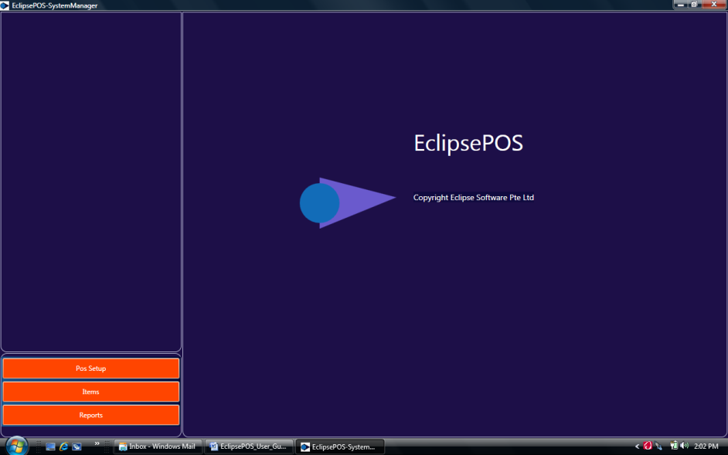

Figure - EclipsePOS system manager

Your first task in the system manager is to setup the data source.

Choose POS setup and then manage data source option.

Select 'create a database with demo data' option.

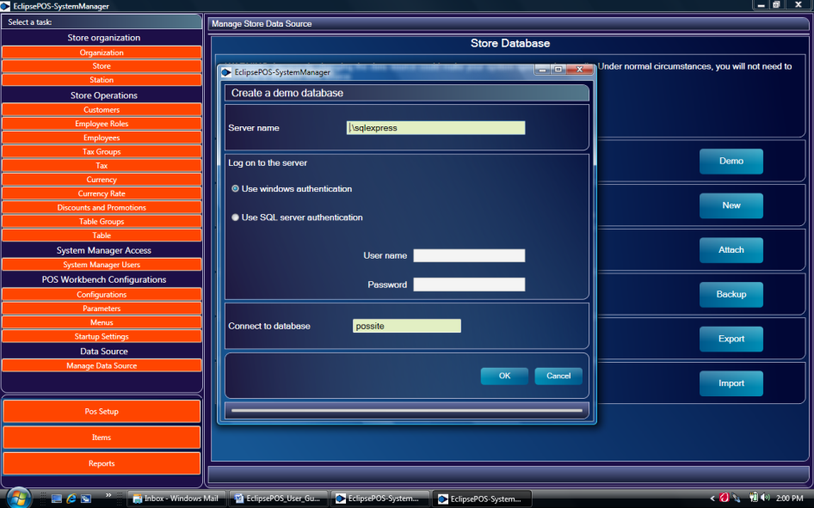

Figure - Create a demo store database

From 'Create a demo database' dialog box, accept defaults and select OK.

Navigate to Startup setting from pos setup.

**EclipsePOS system manager-> Pos setup-> Startup Settings**

You will be prompted to login.

Login with default user name 'admin' and password 'admin'.

If you want to configure the EclipsePOS for a Retail operation, please set following parameters and save it.

Organization: - 1-Eclipse Holding

Store: - 2-WOS Plaza

Station: - 105-Corner store

Configuration: - 1- Retail

Receipt Print Immediate True

If you want to configure the system for a Restaurant operation, then select following:

Organization: - 12 - ACME Restaurant Pte Ltd

Store: - 20-ACME Restaurant - Air Port Terminal 1

Station: - 125-Coounter 1

Configuration: - 1- Retail

Receipt Print Immediate False

Remember to save the settings.

This completes the System manager setting to use demo data.

## Installing POS for .Net 1.12

EclipsePOS uses Microsoft POS for .Net API 1.12 to communicate with POS peripherals. Most of the leading pos peripheral manufacture's make available device rivers for pos for .Net. You need to install POS for .Net 1.12, before installing EclipsePOS workbench.

You can download and install Microsoft POS for .Net 1.12 from following web site:-

<http://www.microsoft.com/downloads/en/details.aspx?FamilyID=EAAE202A-0FCC-406A-8FDE-35713D7841CA&displaylang=en>

## Installing EclipsePOS Workbench

You can download and Install EclipsePOS Workbench from our web site <http://www.eclipsesoftware.com.sg/download.htm>

Installation is easy and you can ignore security warning dialogs that are displayed during the installation.

Once installation is complete you will see EclipsePOS workbench displayed on your PC.

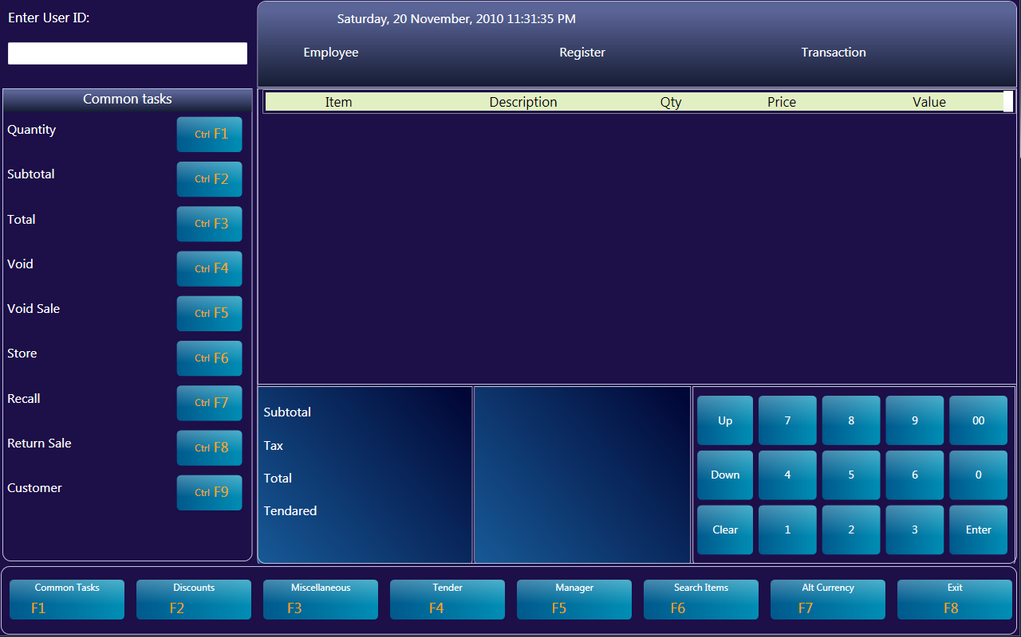

Figure - EclipsePOS Workbench

If you have configured the system for retail operation then logon with user id 100 and password 100.

If you have configured the system for restaurant operation then logon with user id 200 and password 200.

You can use the touchpad keys displayed on the screen or the PC Keyboard to input the data to the system.

(Before installing EclipsePOS workbench you need to install EclipsePOS system manager and configure the database)

## Access Control

Default user id and password to access pos system manager is 'admin' and 'admin' respectively.

To change the system manager access password or add in a new system manager user navigate as follows:

**EclipsePOS System Manager -> POS Setup -> System Manager Users.**

To add in a new Employee to log in to EclipsePOS Workbench

**EclipsePOS System Manager -> POS Setup -> Employee**

## Stopping the system

Press the Exit Button. POS workbench will show the Exit Menu. You can press the Shutdown POS Key to exit from EclipsePOS.

EclipsePOS Workbench-> Exit -> Shutdown

Chapter 3

EclipsePOS System Manager

.

## Architecture of EclipsePOS

Every EclipsePOS workbench needs to know it's organization number, store number, station number and configuration number as it's startup parameters. These parameters are configured within EclipsePOS System Manager.

Organization

Store

Station

Customers

Employee Rolls

Employees

Tax Groups

Tax

Currency Rate

Promotions

Product groups and Products

Configurations

POS Parameters

Menus and Pos Keys

## Navigating though the menus

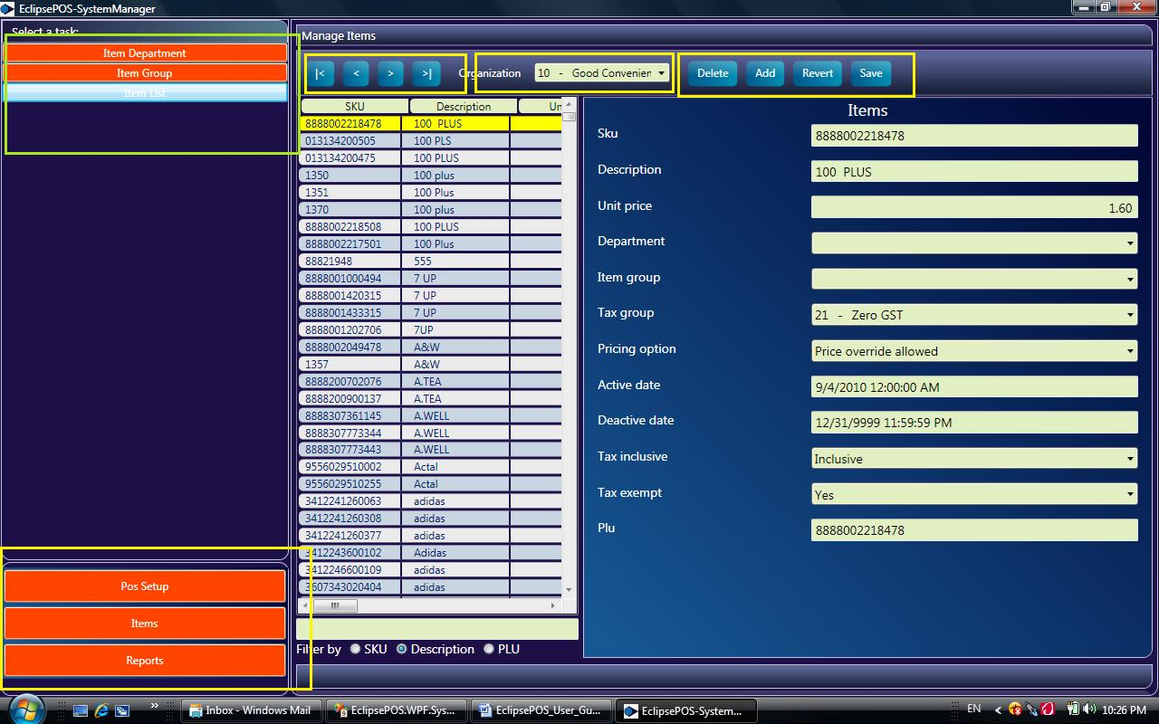

Module navigator keys are located in bottom left of screen. Use the module navigation buttons to navigate Pos setup module, Item module or Reports module.

Task navigation buttons are located on top right corner of the screen.

Following buttons are available on each task:

|< Select the begging record of the list view

< Select the next record of list view

> Select the previous record of list view

>| Select the last record of list view

Delete Delete the selected item from list view

Add Add a new item to list view

Revert Revert changes done to list to the list of records

Save Save change done to the list View

## Setting up the store database

You can setup a store database one of following ways:

### 1. Use the demo database

Create your organization

**EclipsePOS System Manager -> POS Setup -> Organization->Add**

Click the Add button so that it creates a new organization record.

Fill in the required input fields and save changes.

Set the newly created organization as your default organization.

**EclipsePOS System Manager -> POS Setup -> Startup Settings**

Create store and Station data.

**EclipsePOS System Manager -> POS Setup -> Store**

**EclipsePOS System Manager -> POS Setup -> Station**

Save the store and station as your startup parameters

**EclipsePOS System Manager -> POS Setup -> Startup Settings**

Now you can create the rest of parameters such as employee, tax, items etc.

You can also create a new POS configuration if necessary.

### 2. Setup a new database

If you require the store data base without any demo data, you can create a new database.

**EclipsePOS System Manager -> POS Setup -> Manage Data Source->Create an empty new database**

After creating the new database, you can either setup your Organization data as described in section 1 above or import data from a another store as described in section 3 below.

### 3. Import data setting

When creating a second store or when there is requirement to start with a new database, you can export the settings from old database and import into the new database.

Export data from old database

**EclipsePOS System Manage -> POS Setup -> Data source setup -> Export data**

Create a new database as described in section 2 above.

Import data to new database.

**EclipsePOS System Manage -> POS Setup -> Data source setup -> Import data**

Remember to set your startup parameters

**EclipsePOS System Manager -> POS Setup -> Startup Settings**

## Configuring the receipt print

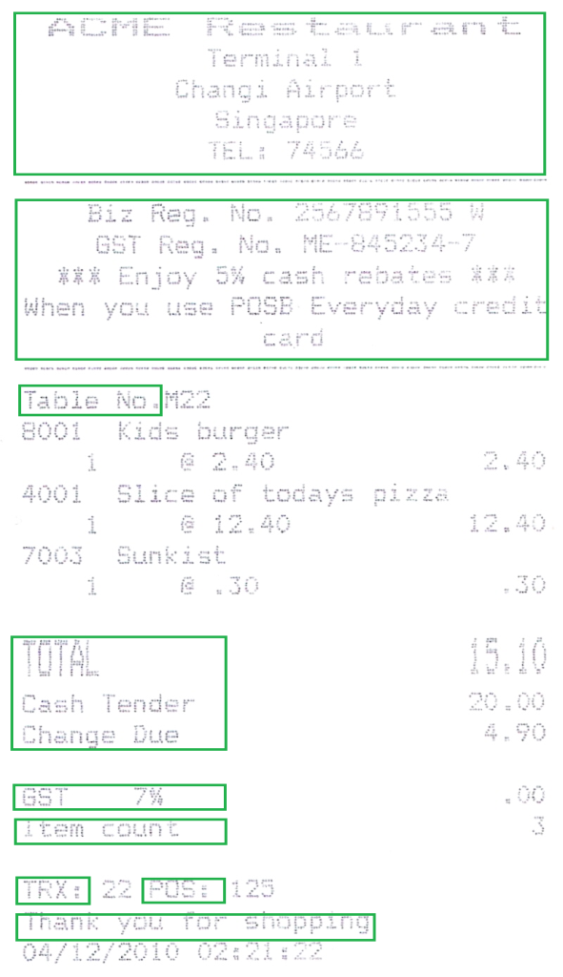

### 1. Receipt Heading

Receipt header text is taken from Store data setup

You can change the store name and address from EclipsePOS System Manager

Navigate to:-

**EclipsePOS System Manager -> POS Setup -> Store**

### 2. Receipt Header Message

Promotional or any other text can be printed on this space.

You can change these texts from parameter setup

**EclipsePOS System Manager -> POS Setup -> Parameters->Receipt Print**

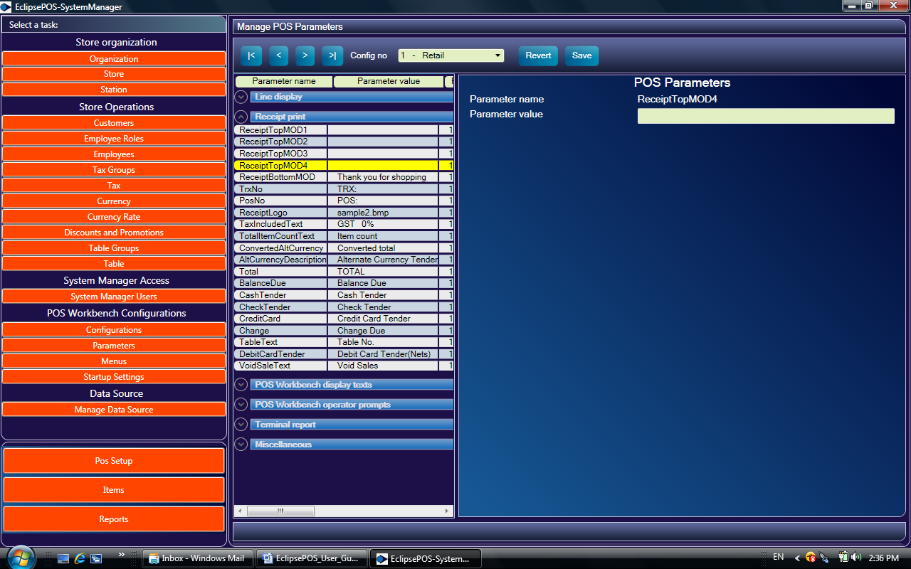

Change following pos parameter values:

ReceiptTopMOD1

ReceiptTopMOD2

ReceiptTopMOD3

ReciptTopMOD4

If these values are blanks then nothing is printed.

### 3. Tax Line

You can change the text for tax line from pos parameters

Navigate to

**EclipsePOS System Manager -> POS Setup -> Parameters->Receipt Print**

Change the 'TaxIncludedText' parameter.

### 4. Item Count Text

Navigate to:-

**EclipsePOS System Manager -> POS Setup -> Parameters->Receipt Print**

Change the 'TotalItemCountText' parameter value.

### 5. Transaction number and Station number text

Navigate to:-

**EclipsePOS System Manager -> POS Setup -> Parameters->Receipt Print**

Change the 'TrxNo' and 'PosNo' parameter values.

### 6. Receipt trailer message

Navigate to:-

**EclipsePOS System Manager -> POS Setup -> Parameters->Receipt Print**

Change the 'ReceiptBottomMOD' parameter values.

## Promotion and Discounts

Following promotional structures are supported.

**Item discount** (Example:- 10% discount for item A)

**Whole order Discount** (Example:- 10% discount for all the items)

**Fixed Amount discount** (Example:- $ 0.20 discount for item A )

**Group discount NForX** (Example:- $ 10.00 for 3 items)

Promotion can be bound to an item or POS Key .

If the promotion is bound to an item then discount is given automatically when item is entered.

Normally you will use this method for Group discount NForX.

If the promotion is bound to a POS key then you need to press the bound pos key (discount button) in pos workbench to effect a discount. Normally you will bound the promotion to pos key for item discount or a whole order discount.

### Crating a Promotion

Navigate to:

**EclipsePOS System Manager -> POS Setup ->Discount and Promotions->Add**

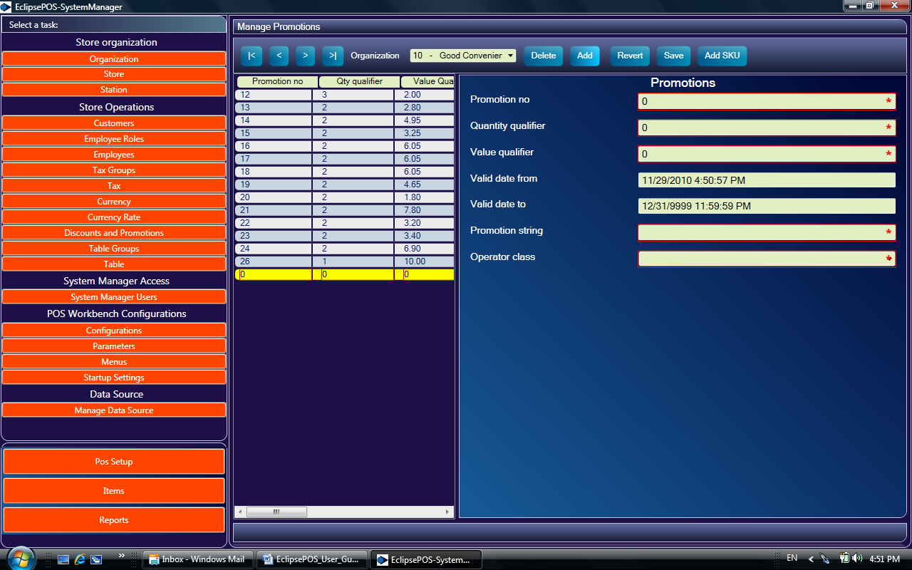

Set the quantity qualifier and value qualifiers based on Promotion class according the following table

|  |  |  |  |
| --- | --- | --- | --- |
| Class Name | Quantity Qualifier | Value Qualifier | Comments |
|  |  |  |  |
| ItemDiscount | 1(not used) | Enter the percentage For example 10.00 | 10% line discount |
| GroupDiscount | 1(not used) | Enter the percentage  For example 10.00 | 10% whole order discount |
| FixedAmountDiscount | 1(not used) | Enter the amount  For example 0.20 | $0.20 discount |
| NForX | Enter the Quantity  For example 3 | Enter the Value  For example 10.00 | Three for $ 10.00 |
|  |  |  |  |

Set the Promotion number, Promotion string and Valid date from/to according to your business needs.

### Binding the Promotion to an Item

Save the promotion created in above step and Click on Add SKU button

**EclipsePOS System Manager -> POS Setup ->Discount and Promotions->Add SKU**

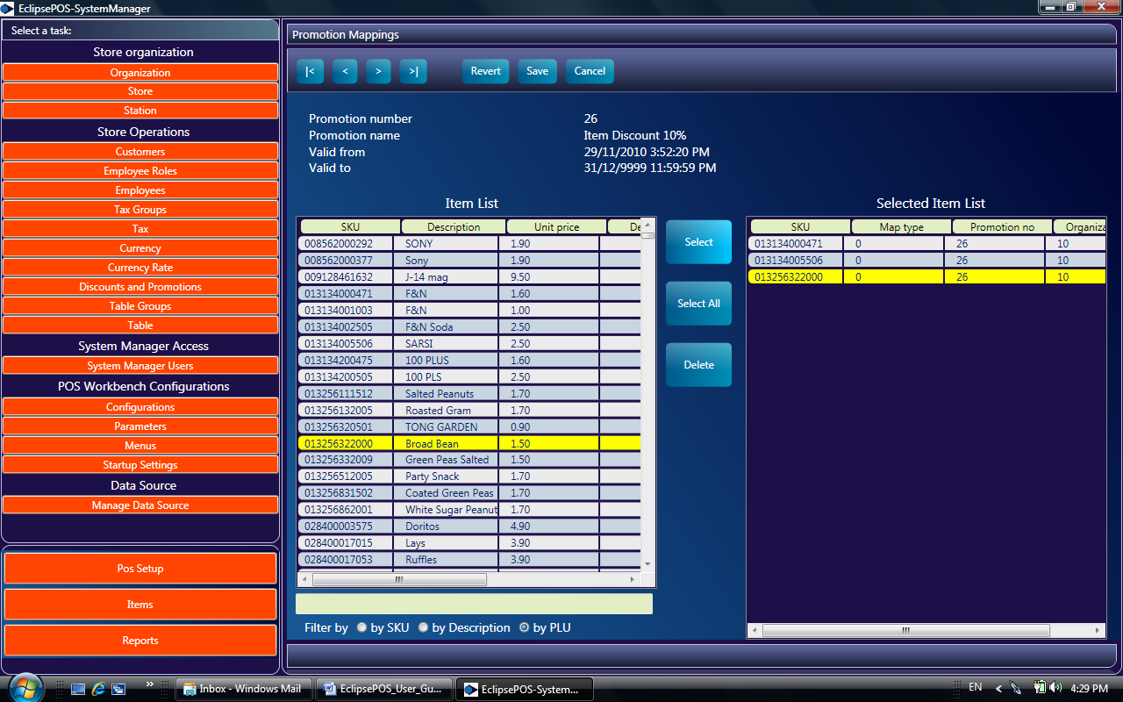

From Promotion Mapping Screen you can select and add item to effect promotion.

Following function are available in this screen

|< Position to First record of items list

< Position to Previous record of items list

> Position to Next record of items list

>| Position to Last record of items list

Revert Abandon changes

Save Save change

Cancel Go back to Promotion Screen

Filter Enter the Filter text and press enter. Remember to select the filter filed before entering the filter text

Select Add the item to promotion list

Select All Add all items to promotion list

Delete Delete the selected item from promotion list

### Binding a Promotion to a POS Key

You can bind a promotion no to a pos key, so that you can effect a discount by pressing a pos key in POS workbench.

Navigate to Menu task from POS Setup. Select the pos panel where you want to add the discount key (Usually the Discount panel) and press the add POS Key button

**EclipsePOS System Manager -> POS Setup ->Menus->Select A Pos Panel->Add Pos Key**

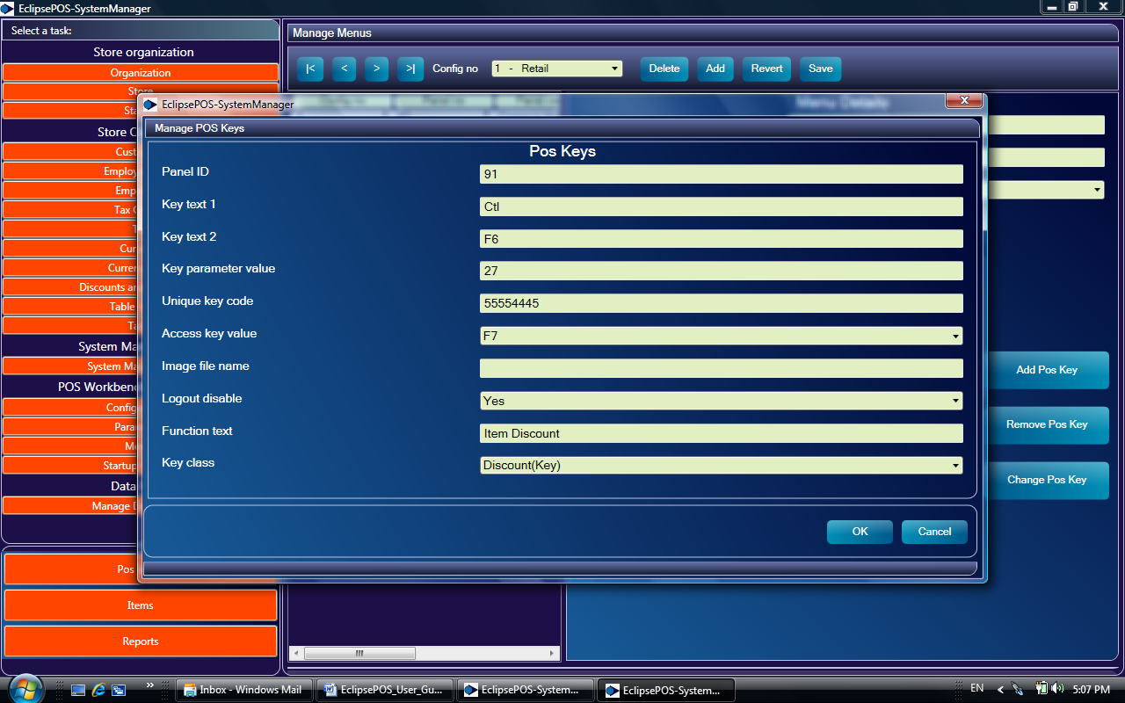

Enter the Promotion no in the Key parameter value

Choose the Key Class as 'Discount(Key)'

Fill in other input field as described in creating menus and Pos Key section in this menu.

Save the menu setting.

Once this step is complete and when you re-start the pos workbench the new discount key should appear in POS Workbench.

## Restaurant specific setups

### Enable/Disable Table select prompting

If you don't need to select a table no at the start of receipt entry then you can disable this feature.

Navigate to parameters from pos setup and change 'PromptForTableNo' parameter to TRUE or FALSE.

**EclipsePOS System Manager -> POS Setup ->Parametes->From Miscellanious group, select 'PromptForTableNO'**

### Select Print receipt Immediate or at end of tender

You can set when to print the receipt from Startup parameter.

**EclipsePOS System Manager -> POS Setup ->Startup Settings->Print receipt immediate**

### Creating menus and sub menus

Often you may need to create menus and sub menus in a restaurant specific setup.

Navigate to Menu setup:-

**EclipsePOS System Manager -> POS Setup ->Menus->Add**

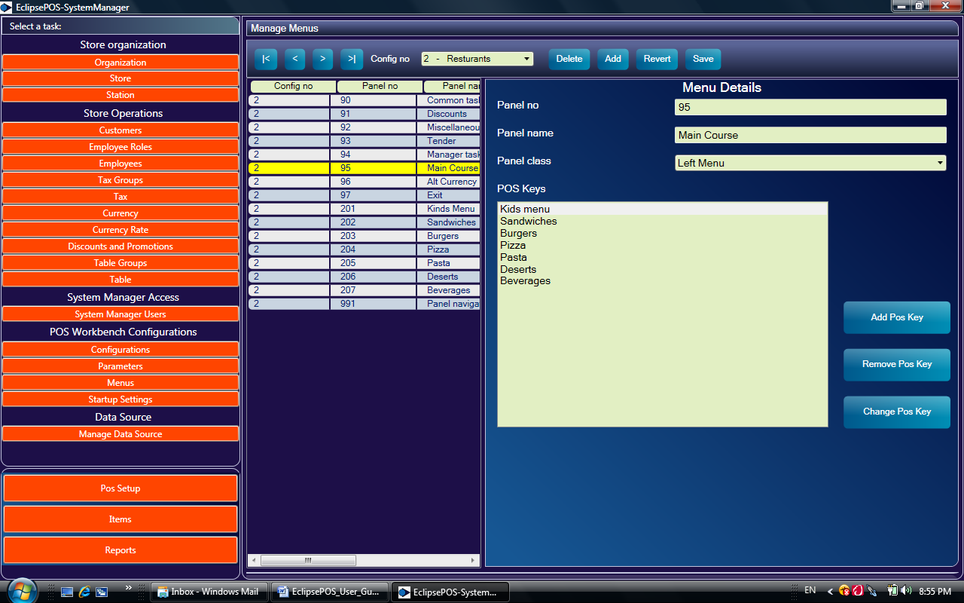

Assign a panel number, Panel name (Menu Name) and choose the panel class 'Left Menu'.

Save the data by clicking the Save button.

Now you can add POS key to this panel by clicking the Add POS key button.

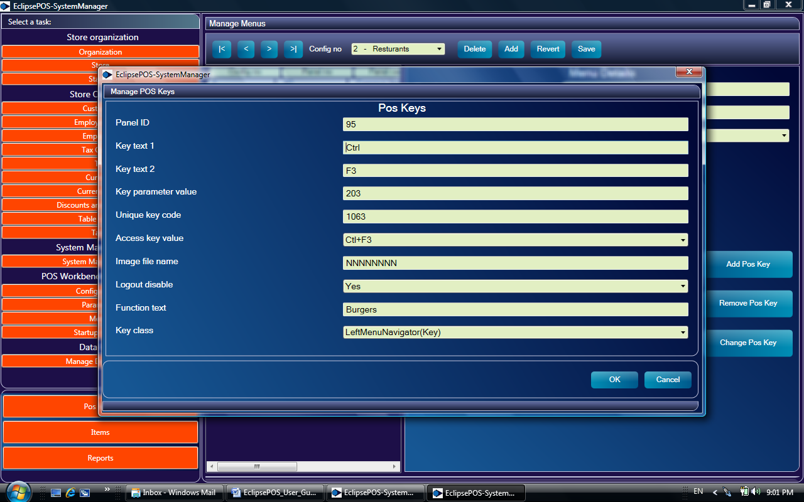

In the POS keys panel, If the POS key should bind to another menu then choose key class '***LeftMenuNaviagator'*** and key parameter value ***panel no.*** you want to navigate to.

If the pos key should bind to an item then choose the key class '***plu***' and key parameter value ***plu number***.

### Setting up Table Groups and Table Layout for restaurants

Before creating the table layout of your restaurant you need to create Table Group Names.

Navigate to

**EclipsePOS System Manager -> POS Setup ->Table Groups->Add**

Assign a group number and a group name. Save the data.

Now you can create table layouts for your restaurant.

Navigatate to

**EclipsePOS System Manager -> POS Setup ->Table -> Add**

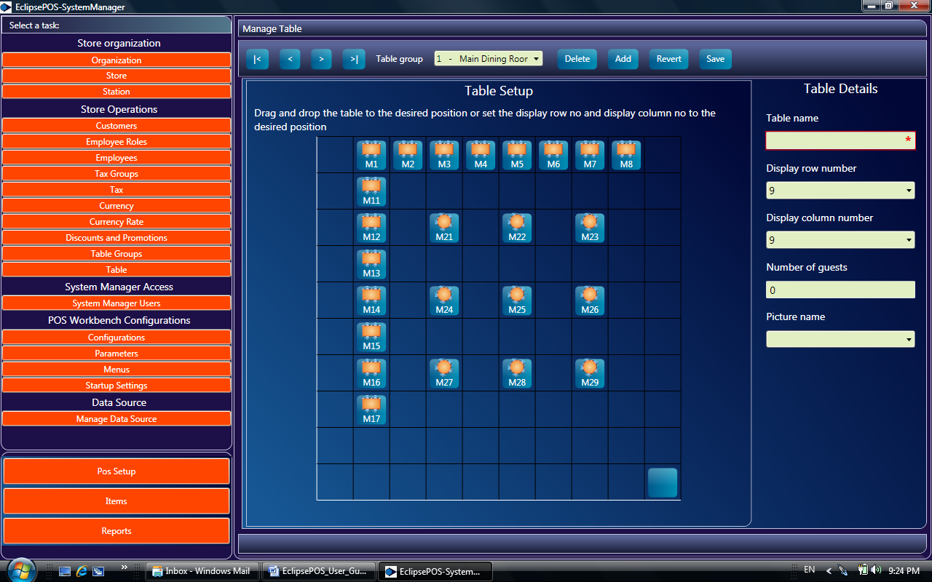

Assign a table name and a picture.

Drag and Drop the table button to desired box.

Save the data. Now this table layout is available in pos workbench.

## Menus and POS Keys

You can easily configure the Left and bottom panels of pos workbench from Menus setup.

**EclipsePOS System Manager -> POS Setup ->Menus**

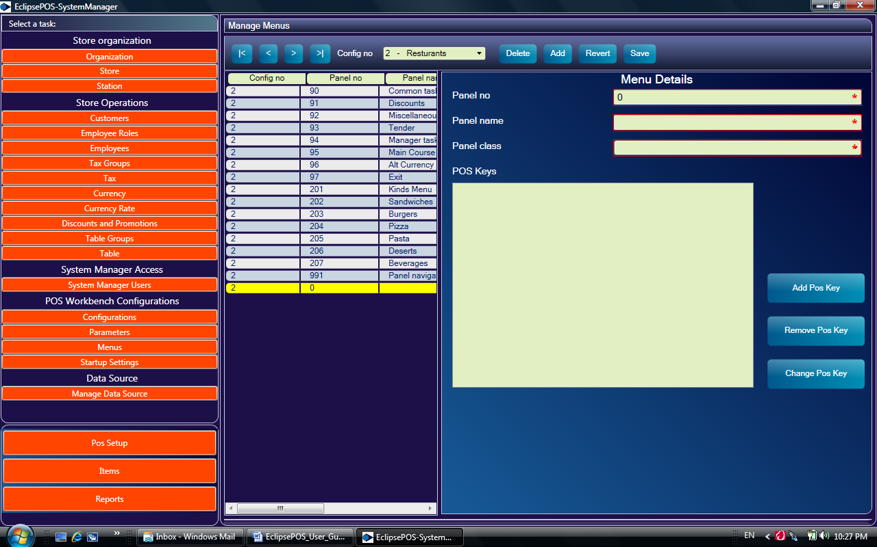

Press Add key to add in a new record.

Assign a panel no. and Panel name. Panel class can be 'Left Menu' or the 'Bottom Menu'. It's best to use the bottom menu as the navigation panel and the left panel for pos operations.

Save the panels and press the add pos key button to create pos keys.

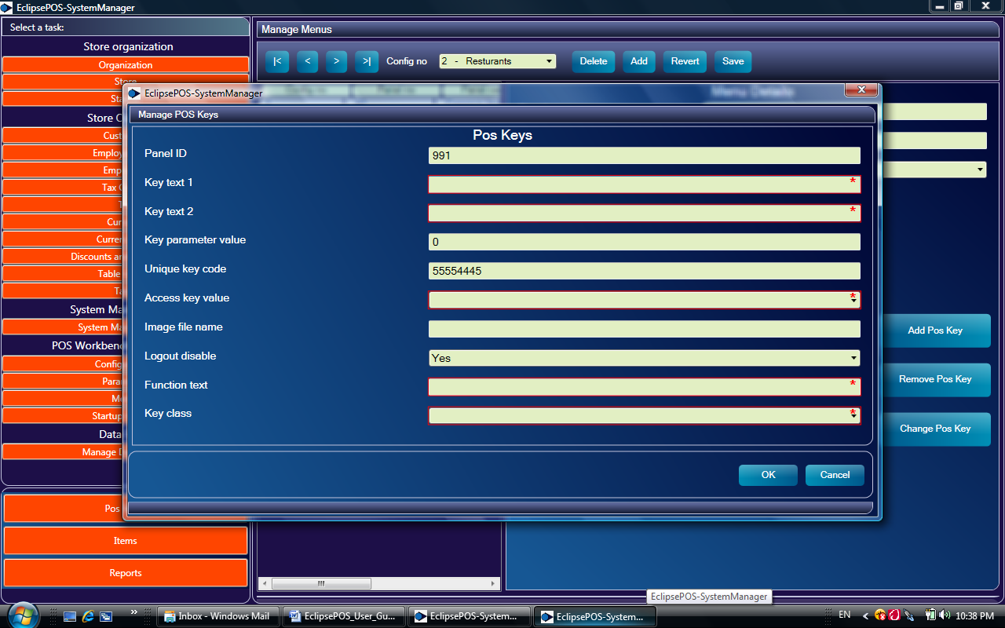

Key Text 1 This text is displayed inside the POS button. Usually it is set as 'Ctl'

Key Text 2 This text is displayed inside the POS button. Usually it is the Function Key

Key parameter value Set the value according to the table given below

Access Key value Keyboard Navigation key

Image File Name Not used at the present. Leave it blank

Logout Disable Yes/No

Function text This text is displayed outside the button along the same line

Key Class Set according to the table given below

|  |  |  |
| --- | --- | --- |
| Key class (Pos Event) | Key Parameter Value | Event description |
| AlphaKey | AscII value | Alpha key event |
| AltCurrTender | Currency code no | Alt currency tender |
| CashTender | 1 | Cash tendering dialog |
| CheckTender | 1 | Check tendering dialog |
| ClearKey | 1 | Clears current pos event |
| Customer | 1 | Customer select |
| CloseCashDrawer | 1 | Used in dialogs |
| CreditTender | 1 | Credit tender |
| Discount | Promotion no | Discount Key |
| DebitTender | 1 | Debit Tender Key(Customer) |
| DebitCardTender | 1 | Debit Card Tender Key |
| EnterKey | 1 | Enter Key event |
| Exit | 1 | Shutdown event |
| ExecScript | 1,2 | 1=Calculator, 2=Note Pad |
| ItemMarkdown | 1 | Item discount(Do not use this directly) |
| ItemVoid | 1 | Void an item line |
| LeftMenuNavigator | Panel no | Navigate to desired panel |
| Lock | 1 | Lock the pos workbench |
| Logoff | 1 | Logoff the pos workbench |
| LogOn | 1 | Logon the pos workbench |
| LookupItem | 1 | Item Search |
| PageDown | 1 | Scroll one line down (Invoice display) |
| PageUp | 1 | Scroll one line up (Invoice display) |
| PaidIn |  | Paid in dialog |
| PaidOut | 1 | Paid out dialog |
| Plu | Plu number | Similar to entering the PLU |
| PriceOverride | 1 | Change Price |
| Quatity | 1 | Change Qty Dialog |
| RecallEj | 1 | Recall a saved receipt |
| ReturnSale | 1 | Return Sale |
| SaveEj | 1 | Save a receipt |
| Subtotal | 1 | Display subtotal |
| Total | 1 | Display total |
| TerminalReport | 1,2 | 1=X-Report, 2=Z-report |
| TrainingMode | 1 | Training Mode (No update to database) |
| Unlock | 1 | Unlock the pos workbench |
| VoidSale | 1 | Void Receipt |
|  |  |  |
|  |  |  |

## Item Master Setup

To setup the store item master, navigate to:-

**EclipsePOS System Manager ->Items ->Items List ->Add**

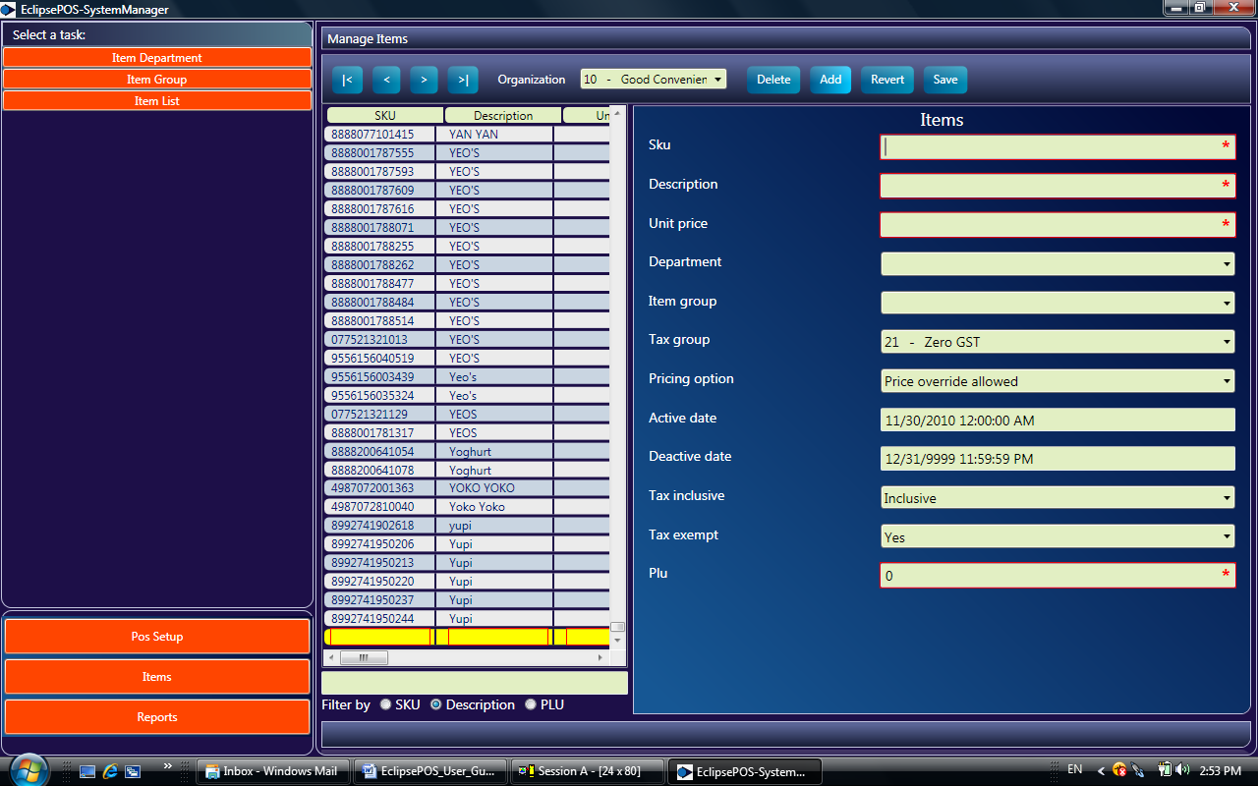

Fill all the required fields.

Active date and Inactive date columns are not used at present.

You can also filter existing items list by Description, SKU or PLU

Select the Filter column and enter the search argument and press enter key.

To amend an item select the row you want to change and change values.

Following function keys are available in this screen

|< Position to First record of items list

< Position to Previous record of items list

> Position to Next record of items list

>| Position to Last record of items list

Delete Deletes a selected Row

Add Add a new Row

Revert Abandon changes

Save Save change

## Parameter Setup

POS Parameter setup allows you configure all text literals that are displayed in POS Hardware and EclipsePOS Workbench.

**EclipsePOS System Manager ->Pos Setup ->Parameters**

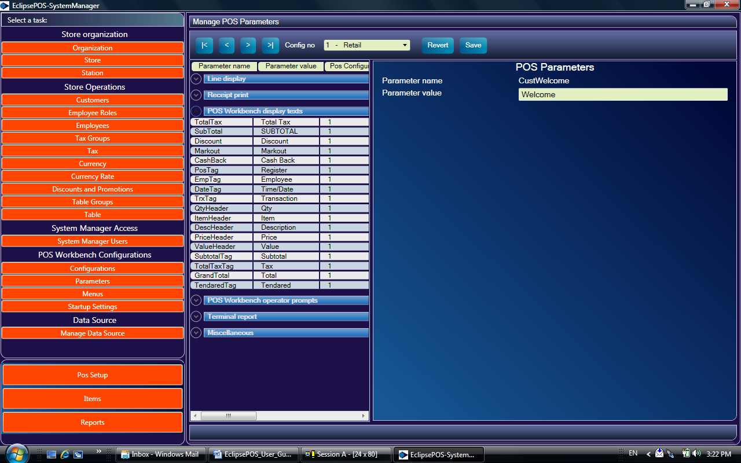

Pos parameters are grouped as follows:-

1. Line Display (Customer display)

2. Receipt Print

3. POS Workbench

4. POS Workbench operator prompt(Error messages)

5. Terminal report ( X-Report and Z-Report)

6. Miscellaneous

You can change all these parameters to suit your business needs

## Securing the store database

Chapter 4

EclipsePOS Workbench

## Navigation through Menus and POS Keys

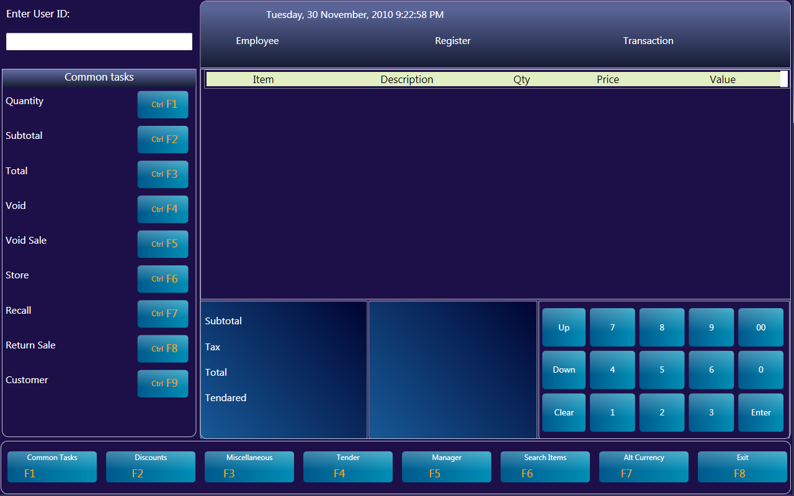

1. Only numeric user id and password are allowed. You can create a new employee user id from theEclipsePOS system manager.

2. If there is an error message on the screen, you can clear it by clicking Clear key or pressing the Del button on the keyboard.

3. Pos key buttons on left and bottom are enabled only after successful login.

4. All pos key buttons on the screen have corresponding keys on your PC keyboard. You can also use the PC Keyboard keys to invoke it.

5. If you have a touch screen then you simply touch the button to invoke it.

6. To enter multiple item quantity, first enter the Quantity number then press the 'Quantity' button.

System will prompt you to enter the item.

7. You can use item's PLU code or SKU code.

8. After printing X-Report or Z-Report, you can press clear key to clear the screen.

## Tending

Following are the steps to accept a cash tender.

Press the cash tender key.

System will show the total amount due.

Enter the amount customer has tendered.

System will show the change due and open the cash drawer.

You can close the drawer and press enter key to complete the transaction.

## Item Search Facility

Items can be searched by description, SKU, department or item group

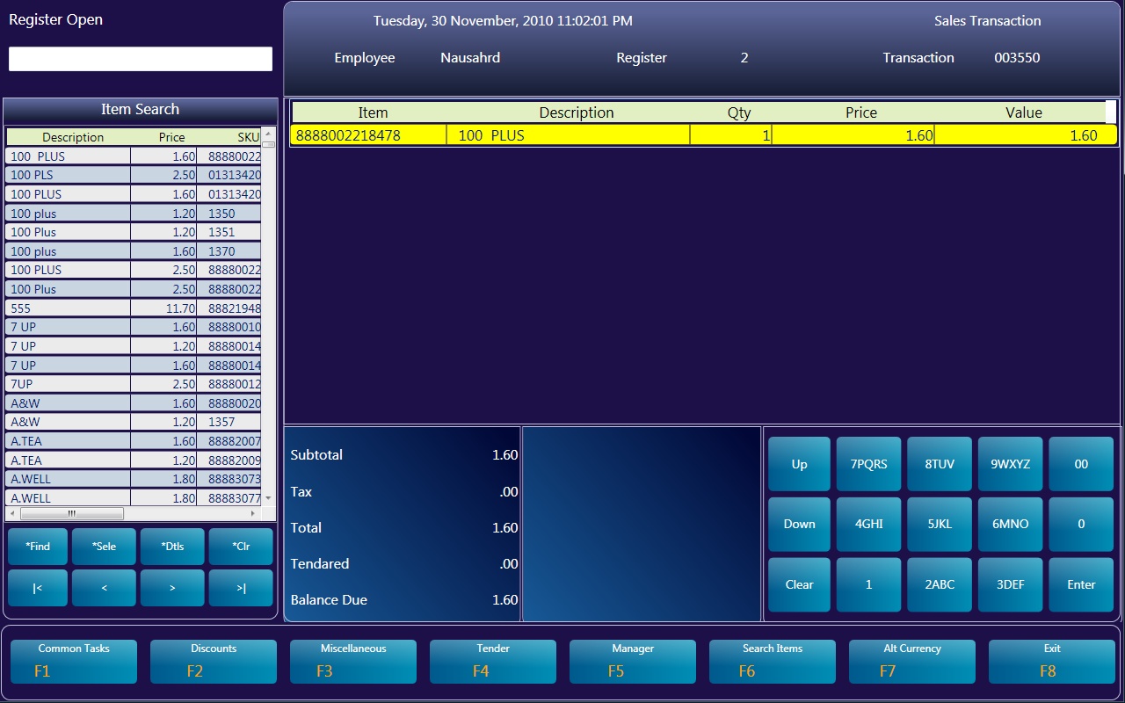

Key in Search argument and press the Find Key (or Ctl + F )

Select the item from search list by pressing the Select Key ( or Ctl+S )

Press Clear (Del) key to go to common task menu.

To display more details of the item press Details Key (or Ctl+D)

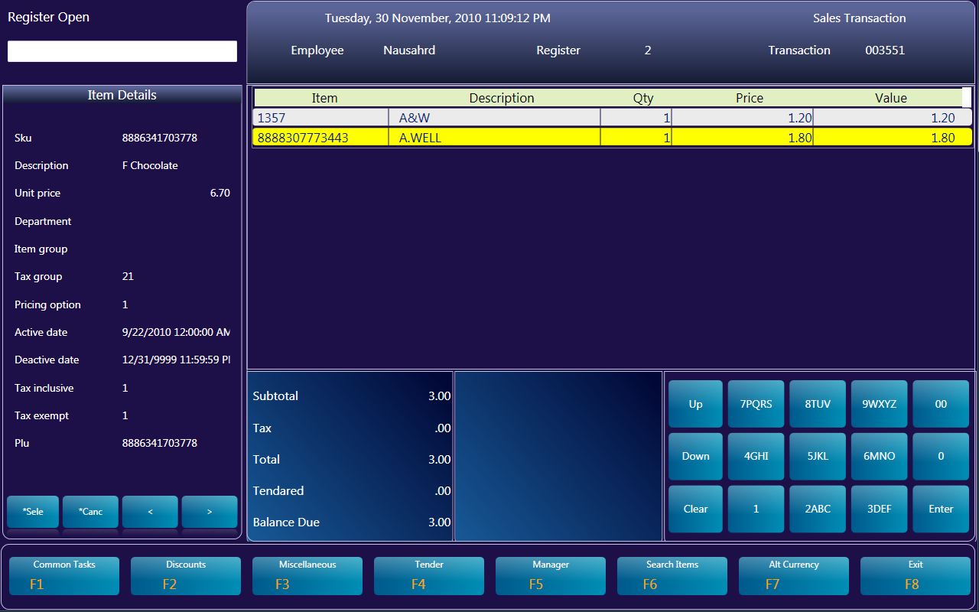

## Saving the receipt in Restaurant Setups

In a table serviced restaurant setup, receipt can be saved and recalled by table number.

To save the receipt press the 'Store' pos key from common functions menu.

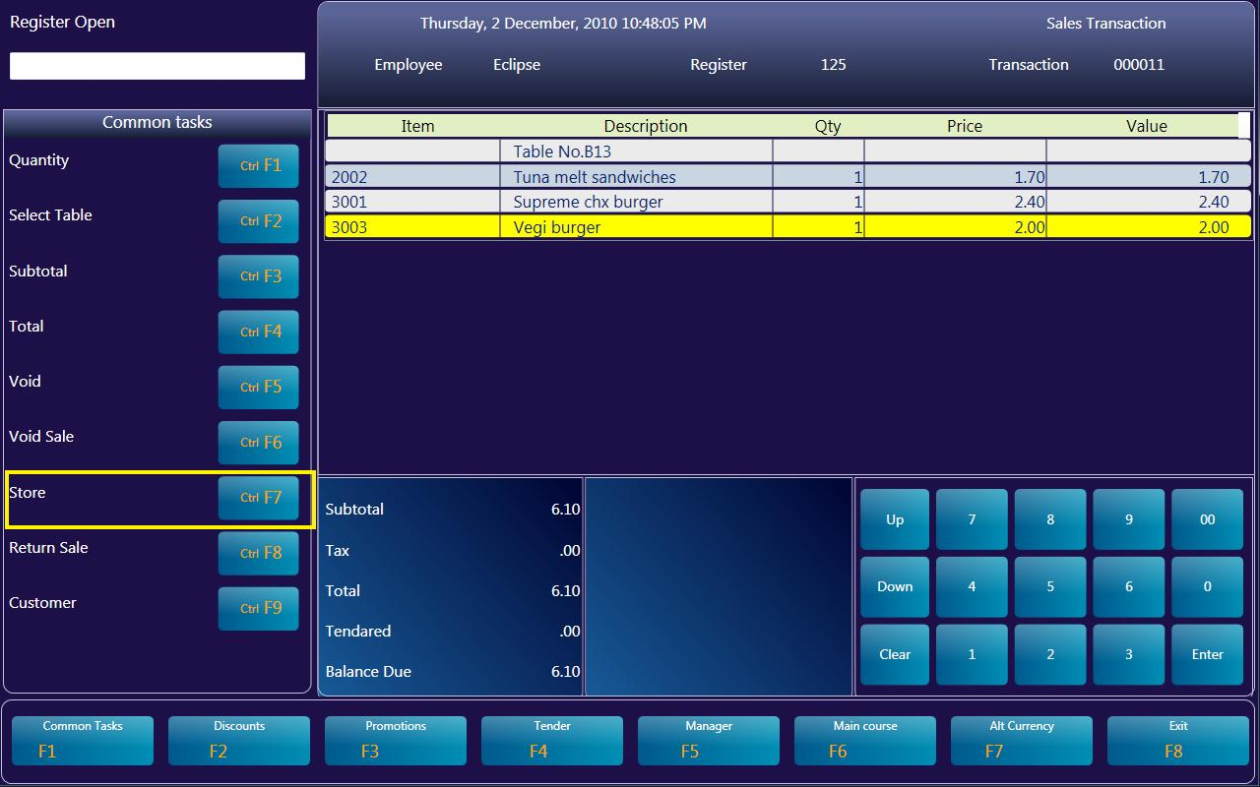

To retrieve the receipt, press the Table pos key from Common task menu.

Select the table group and Click the table button or just enter the table number using the keyboard.

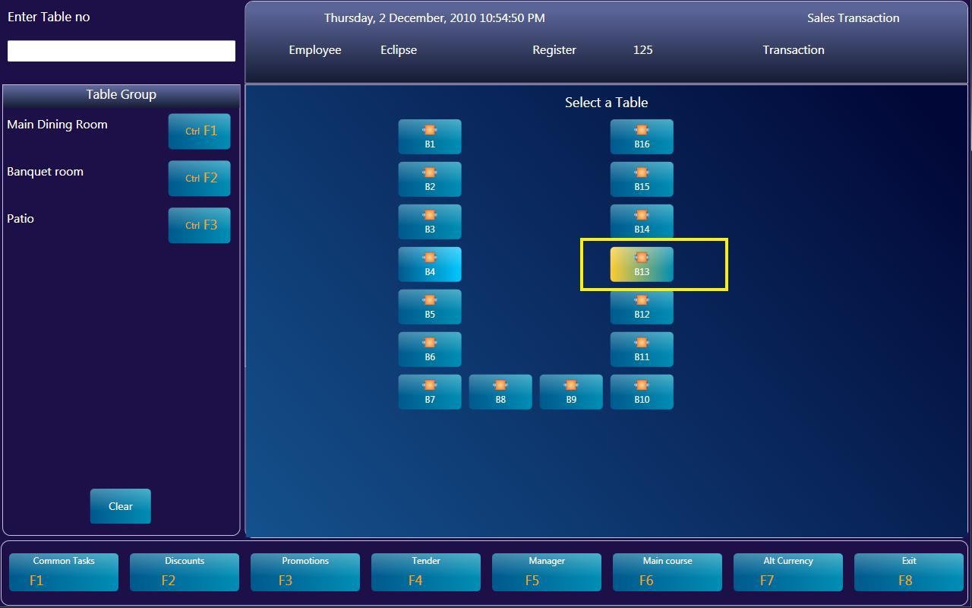

## Changing error Messages and text literals

You can customize all text literals that are displayed on pos workbench from EclipsePOS System manager.

You can find all these text literals in pos parameter setup.

For text literals that are displayed inside and next to a POS button, you can find those in POS key setup.

Chapter 5

POS Hardware Configuration

## Installing POS for .Net Driver

## Check Health Utility

## Assigning a Logical device name